Open the Engagement Engine Rules Editor in the console. Click on “Can’t sign in?”
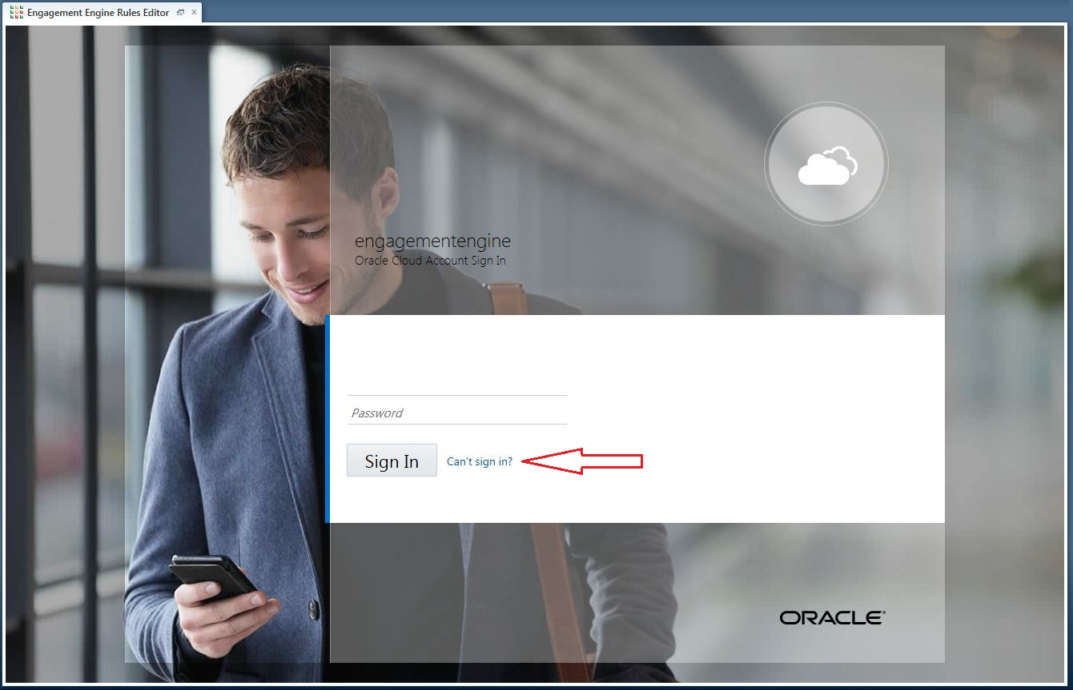

Enter the UserName provided in the “Welcome to Oracle Engagement Engine” email and click “Next”.
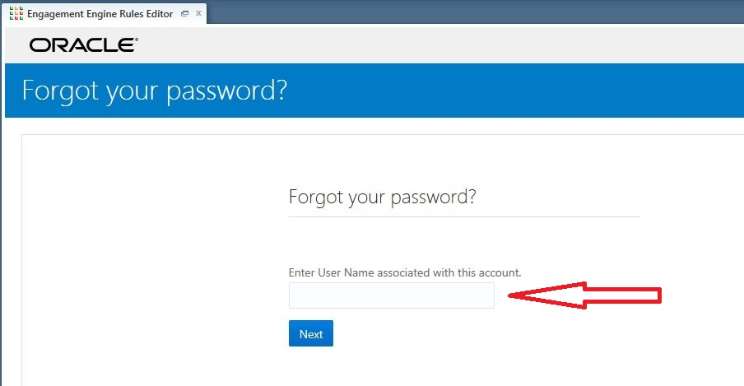
After you click “Next”, you should see this page:

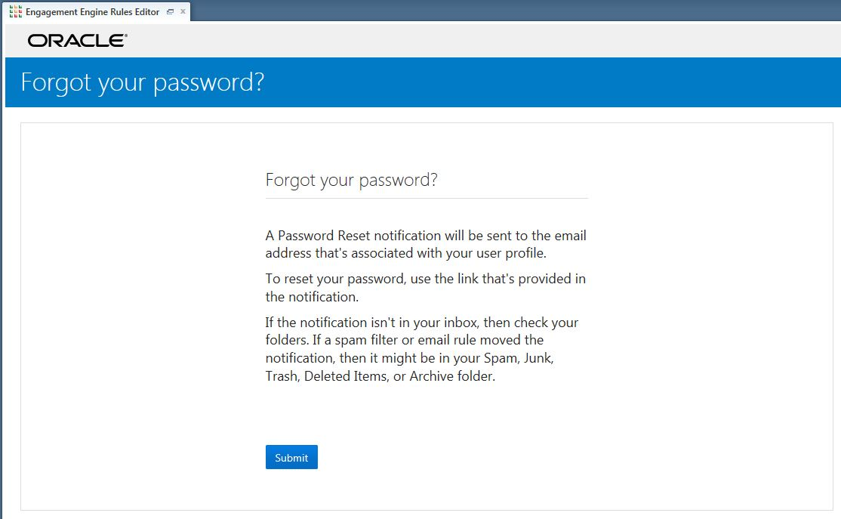

Click “Submit” to complete your request. A Password Recovery Email will be sent to the email address associated with the username. Check your email inbox and click on “Password Reset” (link will expire after 24 hours).

